**AI NEWS SUMMARIZER:**

A Project for Automating News Summarization

This project focuses on streamlining the way we consume news by using AI to summarize articles. With the help of the Hugging Face transformers library, we automatically pull in the latest news from an RSS feed and summarize them into shorter, more digestible formats. The aim is to provide users with relevant news in a quicker and easier way, without the need to read lengthy articles.

**Key components** of this project:

* Fetching current news articles from an RSS feed.
* Summarizing articles using a transformer-based model (distilbart-cnn-12-6).
* Tackling issues like empty summaries or overly long articles.

**Objectives**

- Fetch news articles from an RSS feed.

- Summarize each article using a pre-trained transformer model.

- Output concise, informative summaries of articles.

- Handle edge cases (e.g., missing summaries, long text).

This project automates the process of summarizing news articles. It starts by fetching the latest articles from an RSS feed using the feedparser library. Once the article content is retrieved, it's processed by a transformer-based model to generate a concise summary. The model used, sshleifer/distilbart-cnn-12-6, is specifically fine-tuned for summarization tasks. The result is a clear and concise summary that makes it easy for users to stay updated without reading the full article.

The **key steps** of the project are:

1. **Fetching Articles**: Using feedparser to retrieve articles from a specific RSS feed URL.
2. **Summarization**: Using Hugging Face’s transformers library to process and summarize the article text.
3. **Handling Edge Cases**: Managing situations where the summary might be too lengthy, missing, or requires additional error handling.

**Code screenshots:**

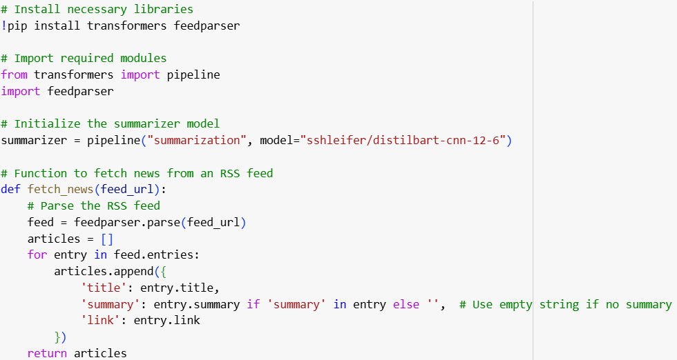

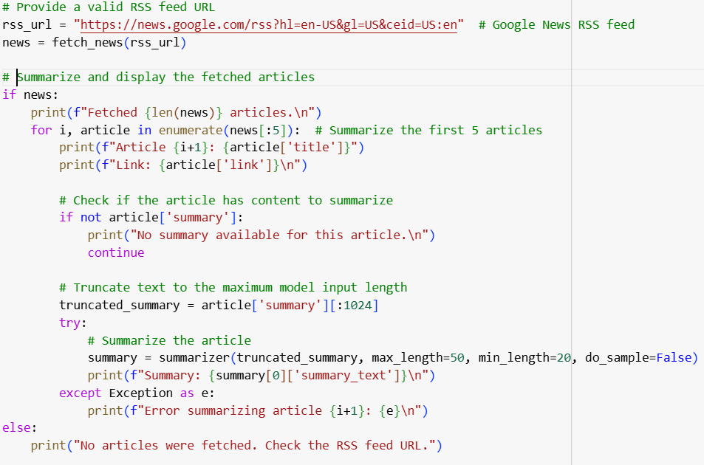

**Output:**

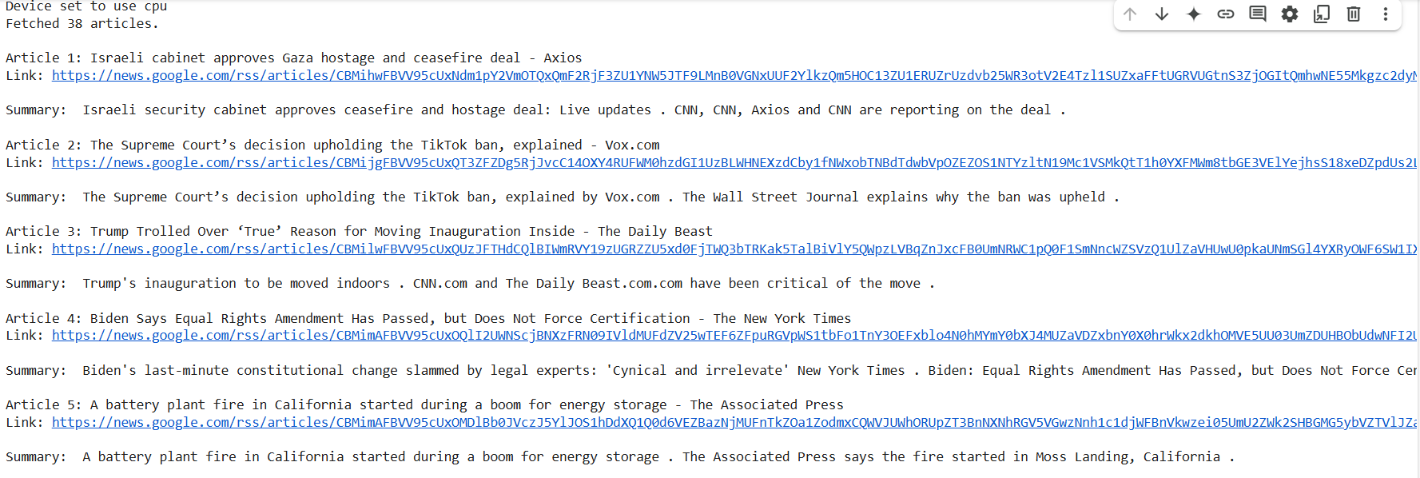

**Key libraries:**

### **1. transformers (by Hugging Face)**

This library provides easy access to pre-trained NLP models like distilbart-cnn-12-6 for tasks such as text summarization. It simplifies using advanced models without needing to train them from scratch, making it ideal for your project.

### **2. feedparser**

Used to parse RSS feeds, feedparser extracts article details like titles, links, and summaries. It helps you easily gather fresh news content from various sources in a structured way.

### **3. torch (PyTorch)**

Although not directly imported, PyTorch powers the transformers library for efficient tensor operations and GPU acceleration. It's widely used in deep learning and is essential for running models like the one used for summarization.

**Google colab link for the code:**

[**https://colab.research.google.com/drive/1UcYtZwE-yuLG0hprHuMU1NWH2UgTs9gY?usp=sharing**](https://colab.research.google.com/drive/1UcYtZwE-yuLG0hprHuMU1NWH2UgTs9gY?usp=sharing)

**Conclusion**

This project demonstrates an AI-powered news aggregator that fetches and summarizes articles using transformers, feedparser, and torch. By automating the collection and summarization of news, it provides users with concise, real-time updates. The system can be expanded further with additional features, showcasing the potential of NLP tools for efficient information retrieval and summarization.